WALMART
Operations Analytics Project
NIL PICKS IMPACT ON
OPD FULFILLMENT PERFORMANCE
Prepared by: Angel Molina | Digital Personal Shopper, OPD Department
Store: Walmart Store #1837
Address: 9451 FM 1960 Bypass West, Humble, TX 77338
Observation Period: April 25 to May 29, 2026
Data Sources: MyWalmart App
Tools: Microsoft Excel • Power BI

Project Summary
This report examines how Not-In-Location (NIL) picks affect fulfillment performance in the Online Pickup & Delivery (OPD) department at Walmart. It was written by a Digital Personal Shopper with firsthand experience in the department, using five weeks of directly observed operational data from April 25 to May 29, 2026.

NIL picks occur when the GIF app directs a picker to a shelf location and the item is not there despite being shown as in stock. Each event forces a substitution or cancellation, eroding First Time Pick (FTP) rates and worsening the customer experience. Data was drawn from the work app used by associates named GIP app (Global Integrated Fulfillment), then structured in Excel and visualized in Power BI.

Key findings:
- Food/Consumables generated 66% of all NIL picks (605 of 919 total events), surpassing by far every other department.
- Out Scans exceeded 13,250 across 15 snapshots. Hardlines, Home, and Food/Consumables showed the highest sustained counts, signaling latent inventory inaccuracy beyond NIL events.
- GM, Grocery, and Frozen/Dairy/Deli received 89% of all inbound freight. Delays working this freight to the shelf are a direct upstream driver of NIL events.
- Freight completion averaged 74.5%, ranging from 50% to 100%. Lower completion days showed higher NIL counts in the same shift.
- FTP averaged 94.0%, never reaching the 95%+ target on any observation date.

Recommendations address the root causes of NIL Picks through smarter inventory management, targeted stocking, demand-driven replenishment, and safety stock adjustments.

1. Business Problem
What Is a NIL Pick?
A NIL pick is recorded when a Digital Personal Shopper arrives at an assigned shelf location for an item and it is absent, even though inventory shows it as in stock. This differs from a standard out of stock, which reflects an expected inventory depletion managed in advance. A NIL is a live discrepancy between system data and shelf reality, discovered only during a pickwalk.

In OPD, pickers use the GIF app to navigate optimized pick paths through the store. When GIF sends a picker to a location with no item, the picker must flag the NIL and initiate a substitution or removal, which adds time and creates a potential negative outcome.

Why NIL Picks Matter
NIL picks affect performance at every level. For the picker, they add unproductive time and create pressure since FTP (First Time Pick Rate) is a stat tracked closely by store leadership. For the department, repeated NILs in the same locations point to inventory accuracy failures that picking effort alone cannot resolve. For the customer, items that cannot be substituted are dropped from the order, directly impacting satisfaction and repeat orders.

Operational Impacts
- Reduced FTP: NIL picks lower the percentage of items located on the first attempt, the store's primary OPD efficiency metric.
- Inventory Accuracy Erosion: High NIL rates signal that system on-hand counts do not match physical stock, compounding replenishment decisions.
- Customer Experience: Items dropped from orders increase complaint rates and reduce trust in curbside and delivery services.
- Associate Pressure: Pressure put into the picker to not NIL pick an item and only do so if the item is really not in the place, which sometimes forgets about how some items are located in multiple locations but not all of them are saved in the system.
2. Operational Environment
Walmart Digital Fulfillment
Walmart's OPD department (Online, Pickup and Delivery), also referred to as OGP (Online Grocery Pickup), covers curbside pickup and same day delivery. Digital Personal Shoppers fulfill orders using the GIF app, which routes pickers through the store using live inventory data. As digital order volume has grown, OPD has become a critical revenue channel requiring tight coordination between pickers, stocking, and receiving teams.

Receiving & Inventory
Freight arrives from distribution centers and DSD vendors and is classified into four statuses: Planned, On the Way, Arrived, and Complete. The key risk for OPD is freight that has been received and logged as in stock but not yet worked to the shelf, creating phantom availability that generates NIL picks when pickers arrive at empty locations.

Inventory accuracy is tracked via SKU vs. Book % and Inventory vs. Sales %. During the observation period, SKU vs. Book deteriorated from -7.5% in late April to -13.1% by mid-May, a widening accuracy gap that directly coincides with elevated NIL rates in the later half of the study. Shrink ran at -$1.3M actual vs. a -$1.5M plan, meaning the store was favorable to shrink budget, even though the worsening SKU accuracy suggests inventory displacement beyond traditional theft was contributing to the NIL environment.
3. Data Collection & Methodology
All data was collected between April 25 and May 29, 2026. The Data Collection shows 11 dates with only a couple of them taken at various times of the day, leading to 15 KPI observations, 90+ freight records, and three complete NIL/Out Scan breakdowns by department.

Three types of data found in MyWalmart App: the KPI dashboard (Sales, FTP %, NIL Picks, Out Scans, GIF metrics), the freight receiving system (trailer arrivals, pallet/case counts, completion rates), and the NIL tracker (NIL and Out Scan counts by department). Data was structured in Excel and visualized in Power BI.

Metric | Relevance
NIL Picks | Primary outcome variable
FTP % | First-attempt pick efficiency
Out Scans | Inventory inaccuracy indicator
Sales ($k) | Order volume context
Freight Completion % | Replenishment execution proxy
Cases by Department | Freight workload by area
SKU vs. Book % | Inventory accuracy measure
NIL Picks by Dept. | Pinpoints high-risk departments
4. Power BI Dashboard
A Power BI dashboard was built to enable interactive visual analysis of the dataset. It is organized across five pages, KPI Overview, NIL & Inventory Analysis, Trends, Freight Operations, and Freight Completion with cross-filter slicers for date range, department, and freight status.

The dashboard surfaces five key visuals: KPI scorecards for FTP %, total NIL Picks, total Out Scans, and average Freight Completion; NIL Picks and Out Scans bar charts by department; a Sales vs. NIL Picks combo chart; an FTP % trend line with a 95% target reference; and a Freight Completion trend line. Together these visuals make every finding in this report immediately visible without navigating a multi-sheet workbook.
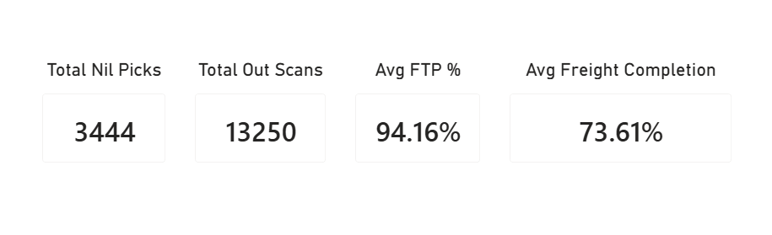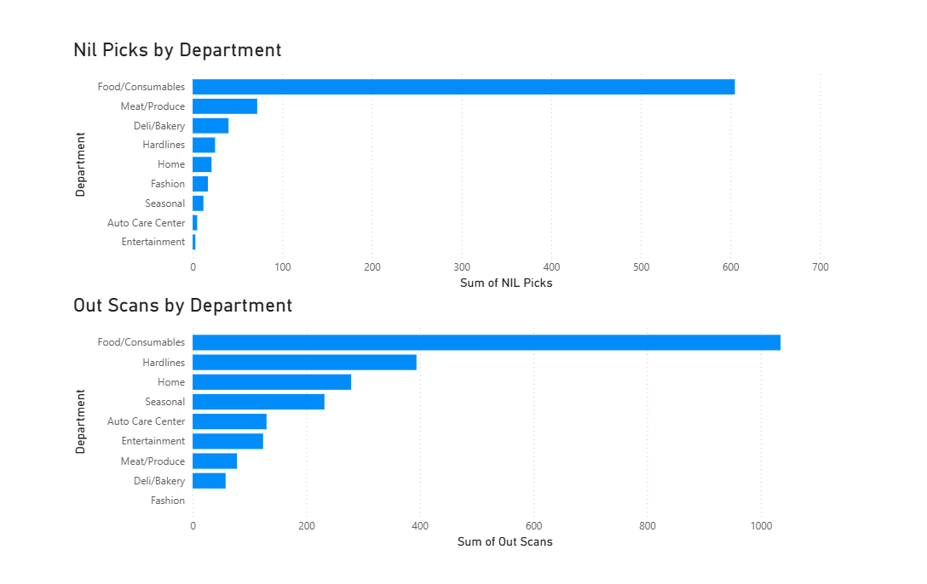

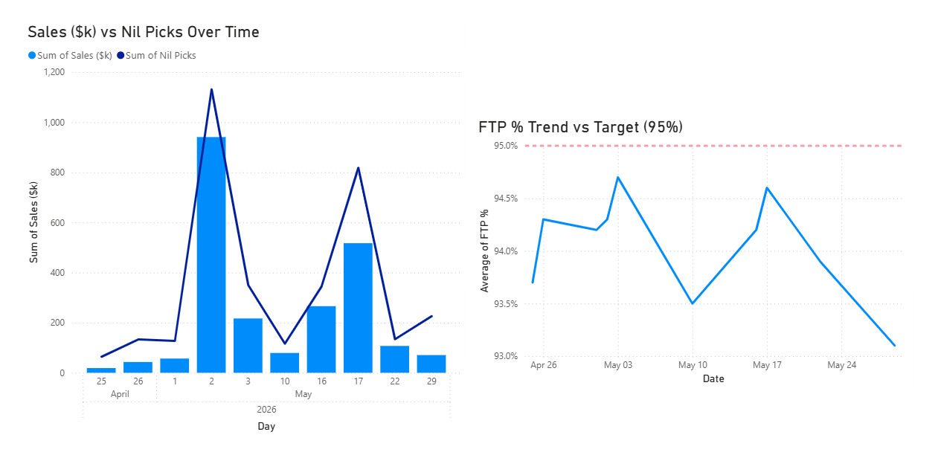
5. Key Findings
Finding 1: Food/Consumables dominates NIL activity
Food/Consumables: 605 NIL picks out of 919 total (66%) across May 17, 22, and 29.

The concentration was consistent across all three observation dates. On May 17, the department logged 321 NIL picks which is more than six times the next-highest department (Meat/Produce at 43). On May 22, the count was 89, and on May 29 it was 195. The May 17 spike followed a freight completion rate of 62.5%, supporting the pattern that incomplete freight in this area directly worsens same-shift NIL rates.

Finding 2: Out Scans signal latent inventory risk
Food/Consumables averaged 345 Out Scans per observation. Hardlines averaged 131, Home averaged 93.

Out Scans reflect items found but not where the system expects them, a persistent location discrepancy rather than a missing item. Hardlines and Home showed elevated Out Scans despite relatively low NIL counts, indicating latent inaccuracy that has not yet converted into NIL events but could worsen. Fashion was the only department with zero Out Scans across all dates.

Finding 3: Freight Workload Concentrates in High-NIL Areas
GM: 39,919 cases. Grocery: 28,737. Frozen/Dairy/Deli: 22,280. Together: 89% of all inbound freight.

The departments with the heaviest freight loads are the same ones most sensitive to NIL risk. Grocery and Frozen/Dairy/Deli form the replenishment backbone of Food/Consumables picking. When over 50,000 cases need continuous processing and execution lags, the system logs product as available before it is physically shelved — creating the phantom availability that generates NIL events.
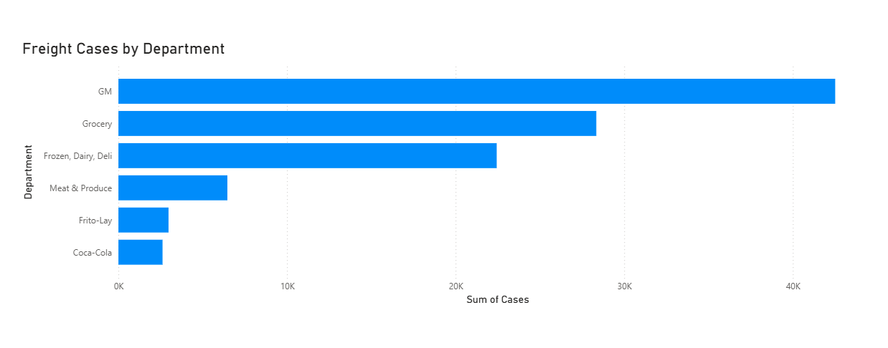
Finding 4: Freight Completion Correlates with NIL Performance
Freight completion ranged from 50% (Apr 25) to 100% (May 2), averaging 74.5% across all observation dates.

On April 25 at 50% completion, 64 NIL picks were recorded which was the lowest in the dataset, though morning order volume was also low. On May 17, 62.5% completion at 1:20 PM was followed by 440 NIL picks by 9:40 PM. The relationship is directional rather than causal given observation timing, but the pattern is consistent showing a lower mid-day completion correlates with higher NIL counts later in the same shift.

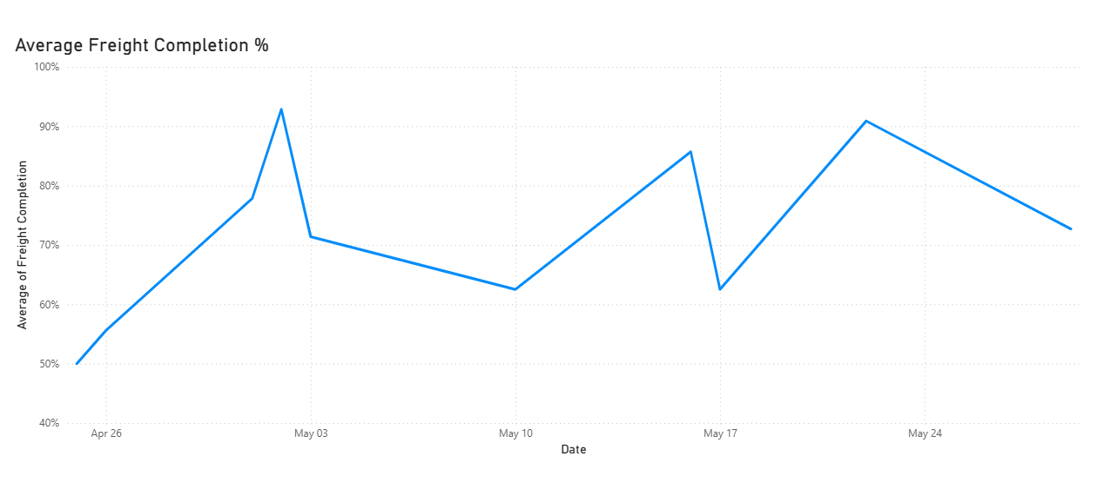
Finding 5: FTP Trails Target Throughout the Period
FTP ranged from 93.1% to 94.7%, averaging 94.0% — below the 95%+ target on every single observation date.

First Time Pick % measures the share of items located and scanned successfully on the first attempt. It never reached 95% across 15 observations, with the metric declining further in the final week. FTP is ultimately a measure of whether the shelf matches the system, a picker cannot improve it through effort alone when items are not where GIF expects them. Reducing NIL picks through better inventory accuracy and freight execution is the most direct way to close the gap.
6. Recommendations
1. Real time shelf inventory detection
The most persistent driver of NIL picks is the gap between what the system believes is on the shelf and what is physically there. Implementing smart shelf technology, such as sensors or weight-based detection systems that update on hand counts in real time as product is removed would eliminate phantom availability at the source. Rather than discovering inventory discrepancies at the moment of picking, the system would reflect shelf reality continuously. This is an infrastructure investment that addresses the root cause and would have the most significant long-term impact on NIL reduction across all departments.
2. Improve Secondary Location Accuracy
Products are frequently relocated to endcaps, action alleys, and promotional displays to increase visibility and sales. However, these temporary secondary locations are not always accurately reflected in the picking system. Through firsthand experience, I have encountered multiple situations where an item's listed location was either outdated or only displayed its original home location, despite the product having been moved elsewhere. When this occurs, associates may record a NIL Pick even though the item is available elsewhere in the store, and the responsibility often falls on the picker for not locating the product.
To reduce unnecessary NIL Picks, secondary product locations should be updated promptly whenever promotional or seasonal displays are changed. Maintaining accurate location information would help associates locate products more efficiently, reduce avoidable NIL Picks, and improve fulfillment performance without requiring significant operational changes.
3. Demand based replenishment prioritization
Not all products replenish with the same frequency, but replenishment schedules do not always reflect actual demand. Items in Food/Consumables that are frequently NIL picked should be flagged for more frequent replenishment cycles, essentially treating them the way perishables are treated, with daily attention rather than scheduled rotation. These items can be identified using existing NIL and Out Scan reports and adjust stocking frequency without requiring system changes.
4. Weather-Driven Demand Forecasting and Safety Stock Adjustments
In Texas, we are very used to sudden weather events such as storms, flash flood warnings, and freeze advisories which create demand spikes for essential items such as water, food, toilet paper and so much more. These spikes are not random; they are triggered by events that are publicly announced hours or days in advance. Despite this, replenishment systems seem to consistently fail to account for them, leaving high-demand items stocked out before the surge passes, and generating NIL picks precisely when OPD order volume is at its highest.
The recommendation is to establish a weather-triggered safety stock protocol so that designated high-risk of stockout items in Food/Consumables should have their reorder points temporarily elevated and replenishment orders accelerated.
7. Conclusion
This project showed that NIL Picks are more than just missed items during a pickwalk or a mistake by a picker. They are the result of inventory accuracy issues, replenishment delays, freight execution, and inaccurate product locations. By analyzing operational data over a five-week period, clear patterns emerged that help explain why certain departments consistently experience higher NIL Pick activity and lower fulfillment performance.

Food/Consumables was consistently the department with the highest NIL Pick activity, making it the greatest opportunity for operational improvement. The findings also suggest that fulfillment performance depends on much more than the picker alone. Factors such as freight completion, inventory accuracy, replenishment timing, and accurate secondary locations all play a key role in reducing unnecessary NIL Picks and improving First Time Pick (FTP) performance.

Throughout the observation period, FTP averaged 94.0%, remaining below the store's 95% performance target. While picker execution is an important part of the fulfillment process, consistently achieving this goal also depends on improving the operational processes that support it. The recommendations presented in this report focus on practical improvements to inventory execution, replenishment practices, freight prioritization, and location accuracy that could realistically be implemented within store operations to make work easier for everybody and improve customer experience and support growth to such a new but fast-growing department like OPD.

